Geometry Test C (Standard) – Worked Solutions
Multiple choice section

Question  Number | 1 | 2 | 3 | 4 | 5 | 6 | 7 | 8 | 9
Answer | B | D | A | B | D | C | C | B | D

Question 1
B
48° + 67° + x = 180
115 + x = 180
x = 65°

Question 2
D
x + 75° + 75° + 50° = 360°
x + 200° = 360°
x = 160°

Question 3
A
a + 47° = 102°
a = 55°

Question 4
B
Between 180° and 360° gives reflex.

Question 5
D
Complementary angles are a pair of angles that add to 90° .
90° – 74° = 16°

Question 6
C
Corresponding angles on parallel lines
are equal.

Question 7
C
RHS – Right angle Hypotenuse Side

Question 8
B
The two angles between sides of different lengths are equal.
Another angle must be 88°.

Question 9
D

Short answer section

Question 10
(a) A rectangle has both pairs of opposite sides equal in length.
(b) Another name for a turn is a rotation.

Question 11
The exterior angle of a triangle is equal to the sum of the two interior opposite angles.

Question 12
(a) 44 + 46 = 90
Complementary angles add to 90°
(b) 21 + 159 = 180
Supplementary angles add to 180°

Question 13
(a) 360 – 278 = x
x = 82°
angles in a revolution

(b) 45.5 + 103.1 + x = 360
360 – 148.6 = x
x = 211.4°
angles at a point

Question 14
AB || CD
∠AGE = 97° (given)
∠AGE = ∠GHC
∠GHC = 97° Corresponding angles on parallel lines

Question 15
AB || CD
a + 68 = 180
a = 112° co-interior angles on parallel lines
b = 68° alternate angles on parallel lines
OR
b + 112 = 180
b = 68°
Supplementary angles add to 180°
c + 68 = 180
c = 112°
Supplementary angles add to 180°

Question 16
Let x represent the size of both angles
2x + 50 = 180
2x = 130
x = 65
∠a is 50° larger than b, 50 + 65 = 115
∠b = 65°

Question 17
(a) 71 + 152 + 74 + x = 360
297 + x = 360
x = 63°
angle sum of a quadrilateral

(b) 34 + 61 + x + x = 360
95 + 2x = 360
2x = 265
x = 132.5°
opposite angles in a kite are equal
Question 18
4x + 12° + 3x + 40° + x° = 180°
8x + 52° = 180°
8x = 128°
x =16°
angle sum of a triangle

Question 19
a + 72°= 180°
a = 108° co-interior angles on parallel lines
72 = 3b – 3
3b = 75
b = 25° opposite angles in a parallelogram are equal
108 = 2c + 4
104 = 2c
c = 52° opposite angles in a parallelogram are equal

Question 20
Decagon has 10 sides, n = 10
(10 – 2) × 180
8 × 180
1440°

Question 21
Hexagon has 6 sides, n = 6
(6 – 2) × 180
4 × 180
Total angle sum of an octagon is 720°.
720 ÷ 6 = 120°
120° is the size of one angle

Question 22
(d) A' (-11, 1), B' (-8, 1), C' (-5, -3), D'(-8, -4)

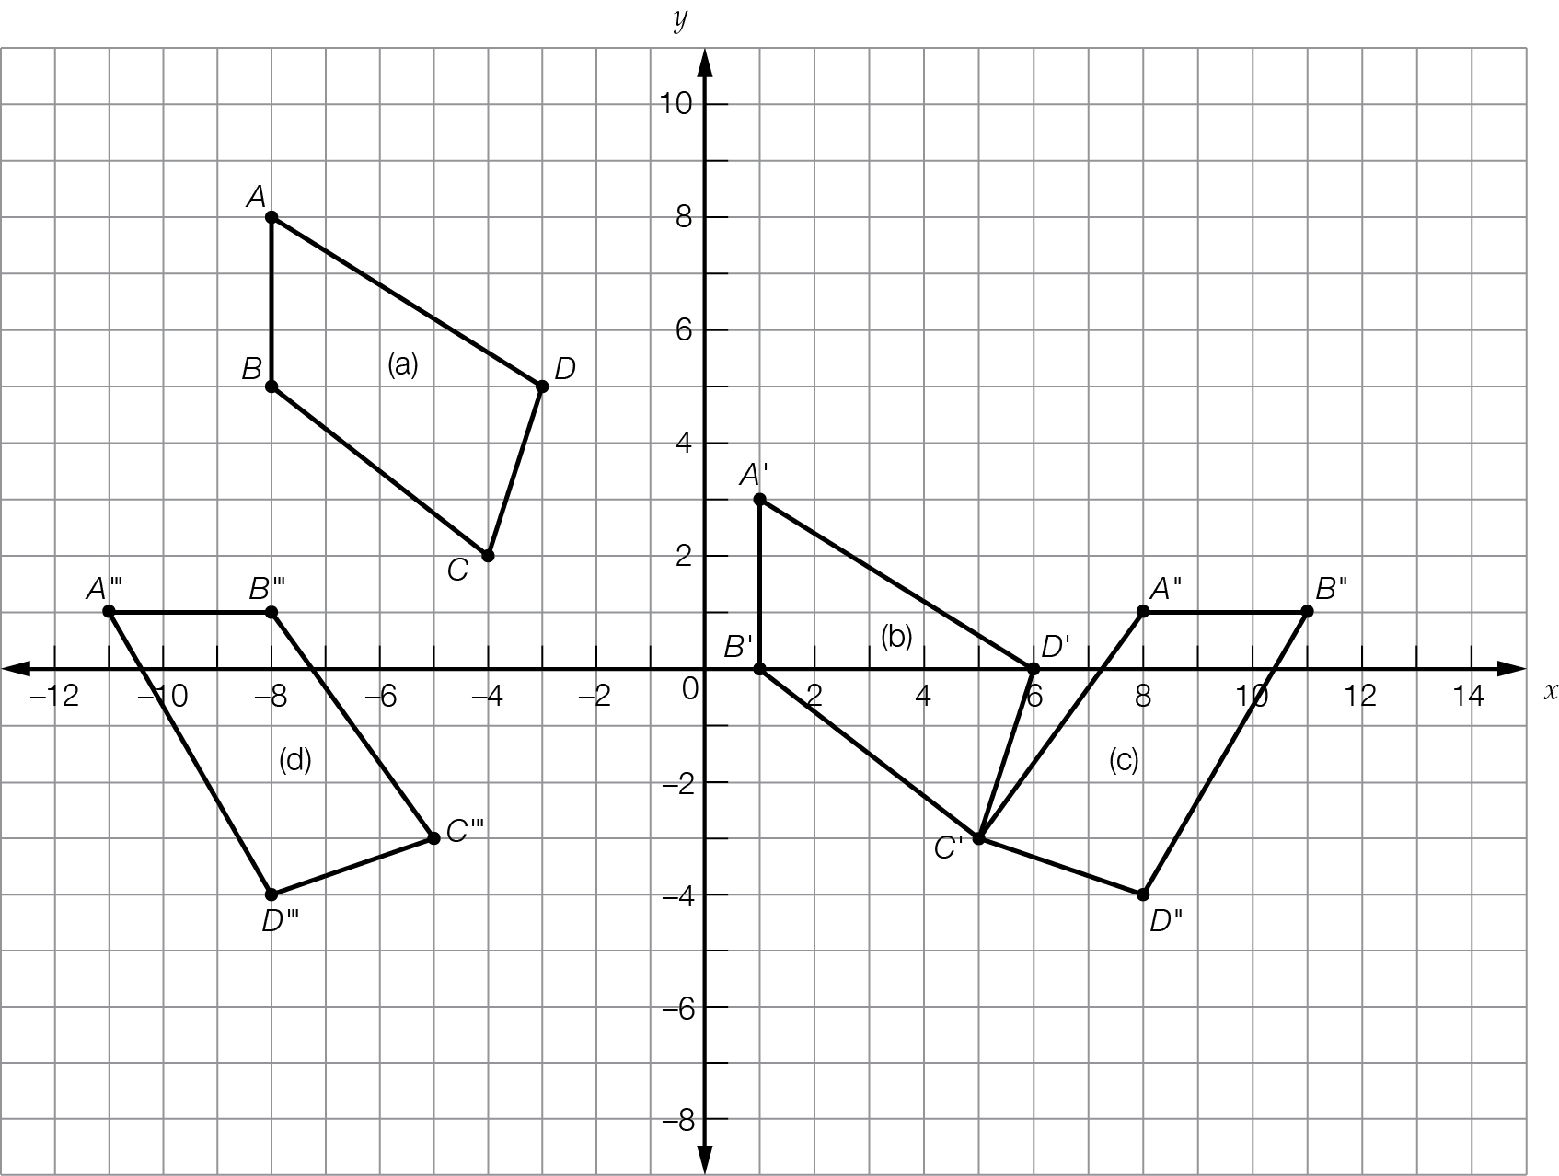
Question 23
∆PTQ ≡ ∆RTS
∆RTQ ≡ ∆PTS

Question 24
x = 5 m
y = 167°

Question 25
(a) AB = DE; AC = DF; BC = EF
∆ABC ≡ ∆DEF
Side, Side, Side, (SSS)

(b) ∠EFD = ∠EDF (isosceles)
∠EDF = 82°

Question 26
Left and right triangles are congruent and are isosceles triangles.
Top and bottom triangles are congruent and are isosceles triangles.
x = 63°, base angle of an isosceles triangle.

Extended answer section

Question 27
(a)
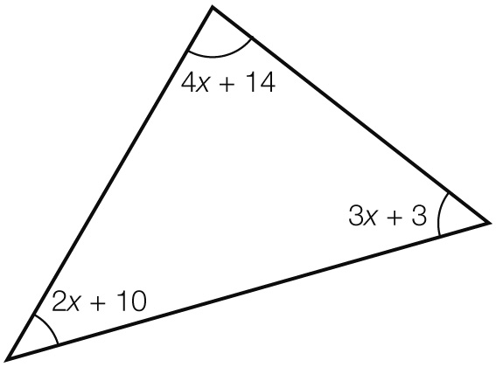

(b) 4x + 14 + 2x + 10 + 3x + 3 = 180
9x + 27 = 180
9x = 153
x = 17
4x + 14 = 4 × 17 + 14 = 82°
2x + 10 = 2 × 17 + 10 = 44°
3x + 3 = 3 × 17 + 3 = 54°

(c) 82 + 44 + 54 = 180

Question 28
(a) a = 81°
corresponding angles on parallel lines
b = 56° alternate angles on parallel lines
c = 180 – 81
c = 99°
supplementary angles add to 180°
(b) ∠BEI—corresponding angles on parallel lines

(c) 81 + 56 + 99 + x = 360
236 + x = 360
x = 124°

